USER GUIDE

EASYTRANSFER

<https://easytransfer.tk/>

1) The below steps must be done before the tranferring can be initiated.

- Search for EasyTransfer (@EasyTransfer_bot)

- Send “Hi” message to the above EasyTransfer to get chat_id

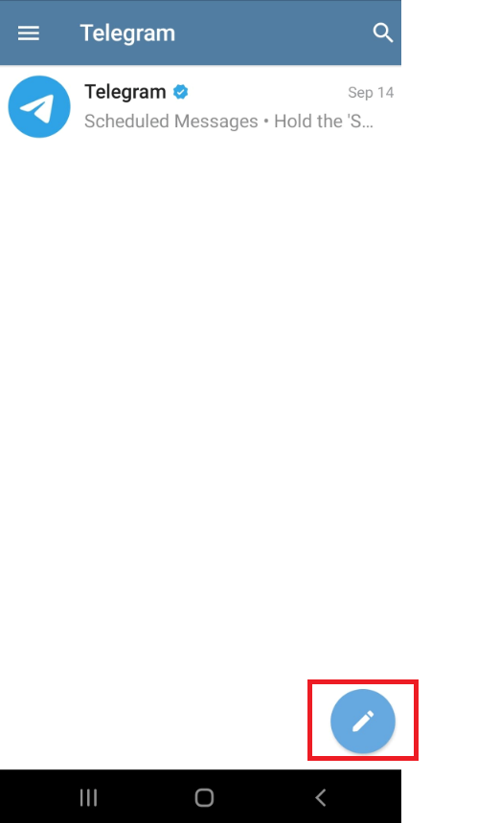 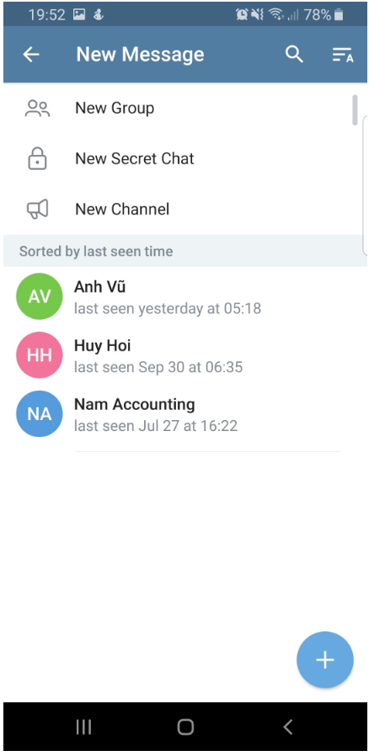

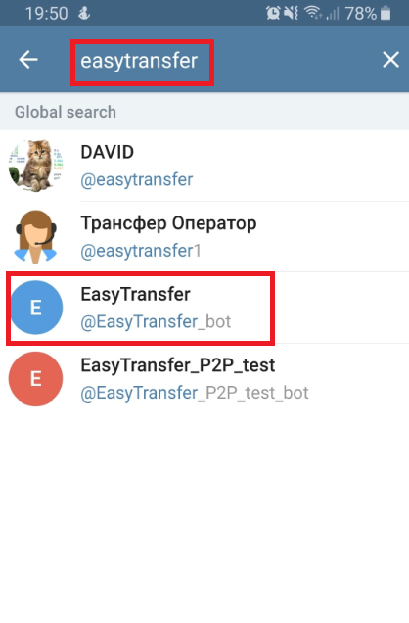 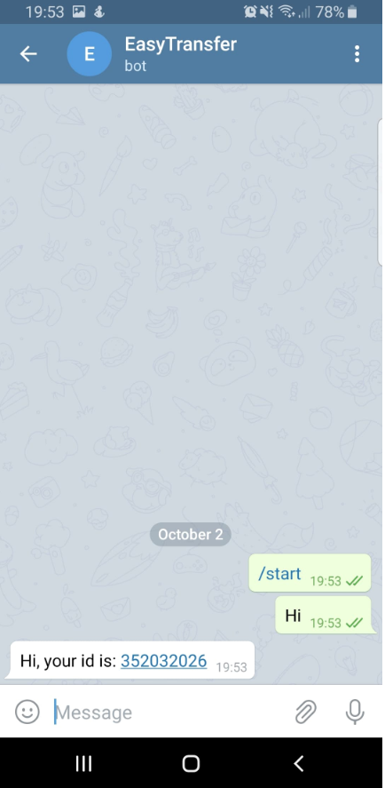

2) Insert URL <https://easytransfer.tk/> in Web browser.

The below snapshot is what will be displayed.

Note: “Verify Number” and “Send” buttons are disabled until the correct chat_id (9 digit number) is validated.

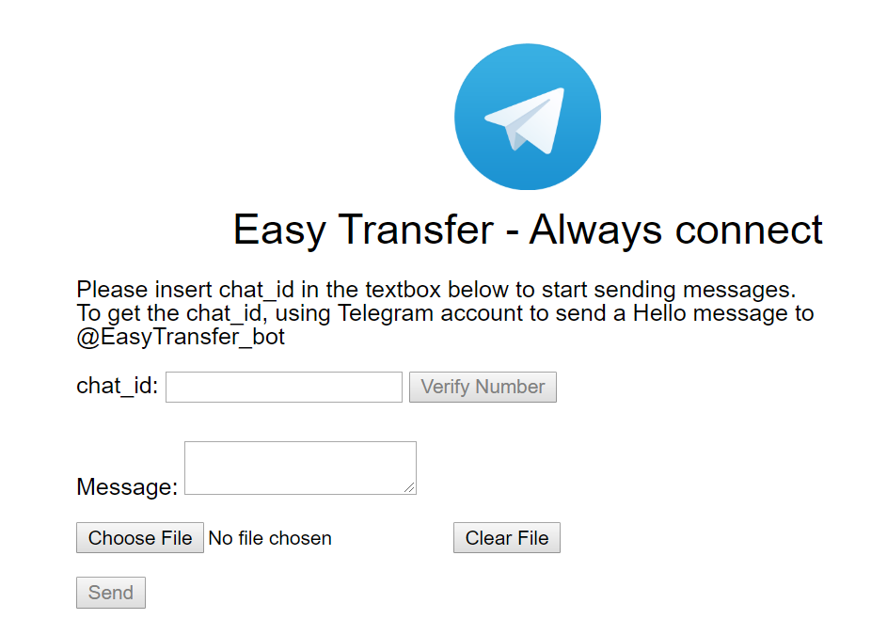

3) Input chat_id (taken from step 1). Now, “Verify Number” button is enable.

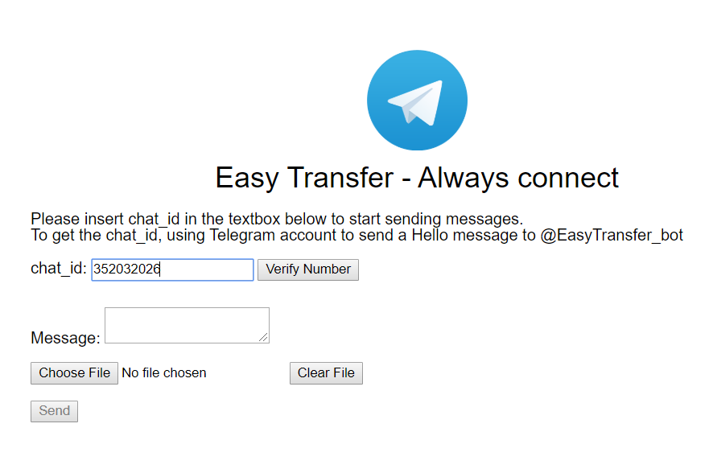

Click on “Verify Number” button

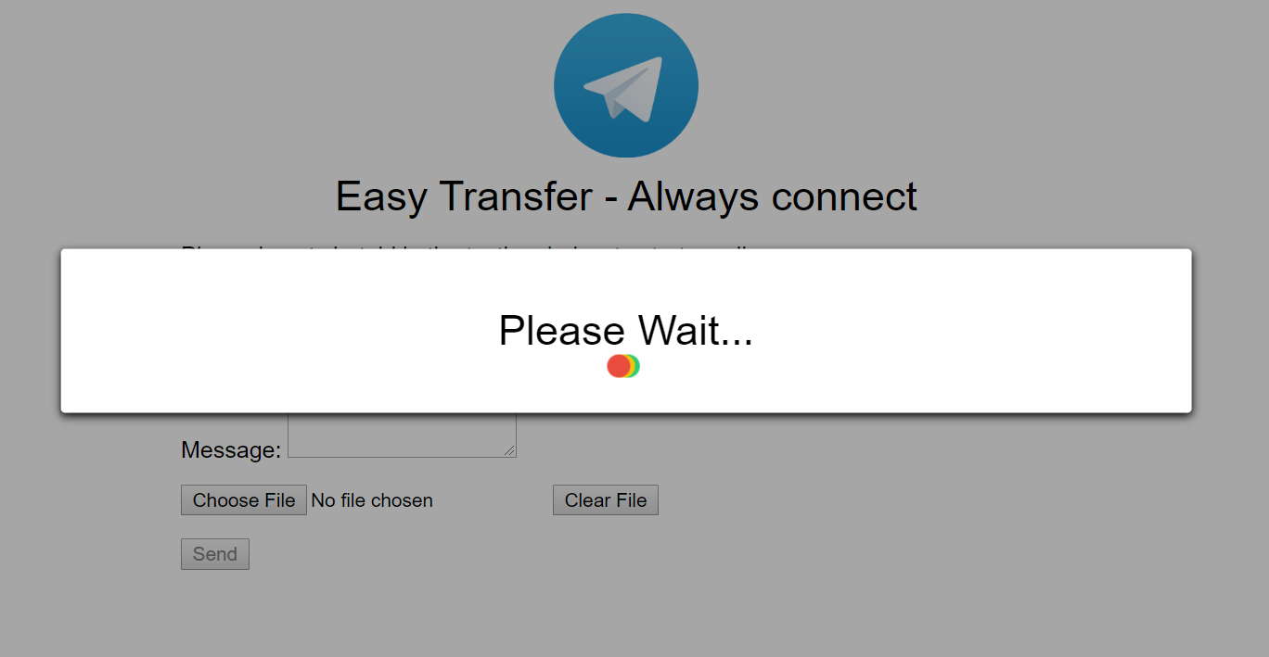

A message (Do you want to receive message from EasyTransfer?) will be sent to receiver’s Telegram account. “Yes” message must be sent back for the process to be continued.

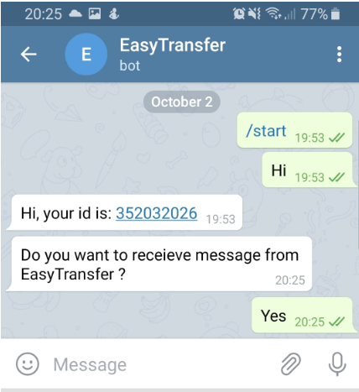

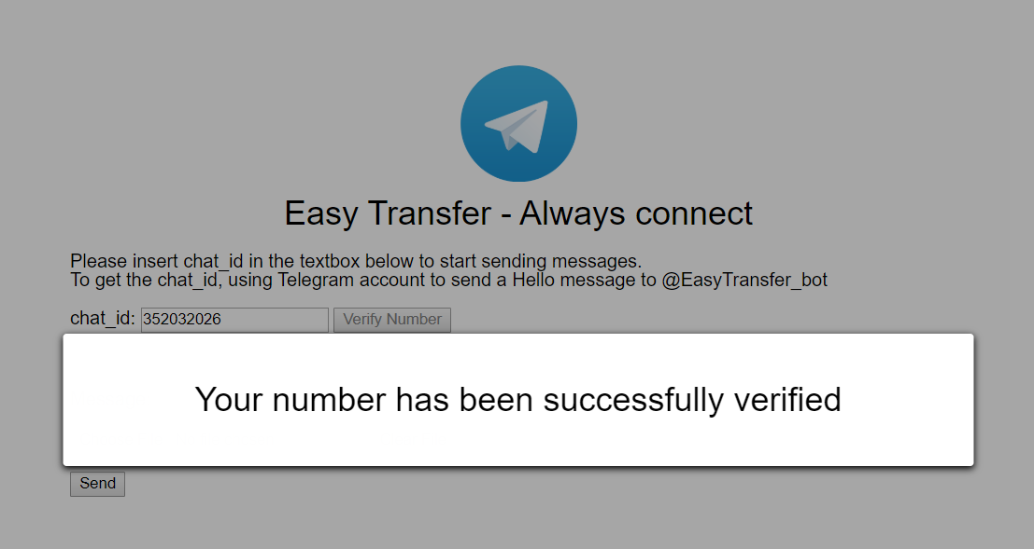

Otherwise, if no message is sent back, the verification will time out after 60 seconds. The below error will be displayed.

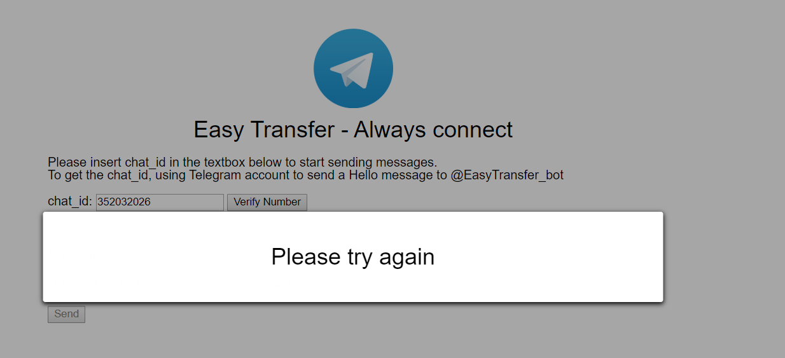

4) Either type in message or attach file to send.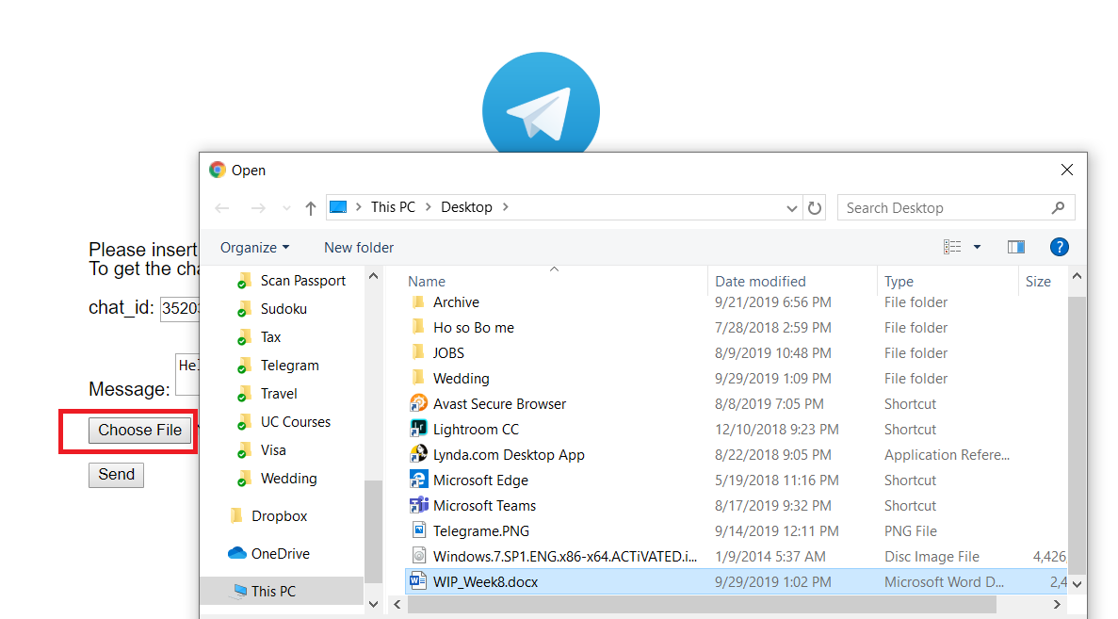

If no message is inserted or no file is chosen, there will be a warning pop-up message as below.

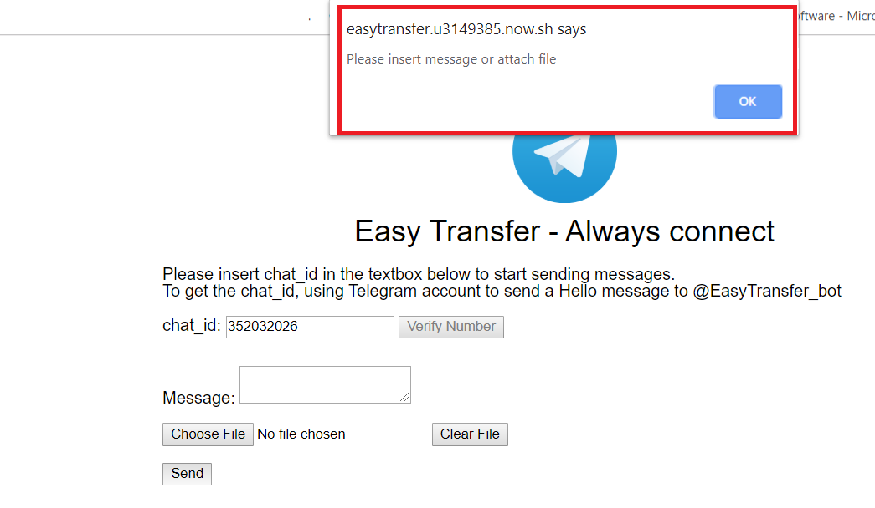

5) Send successfully

